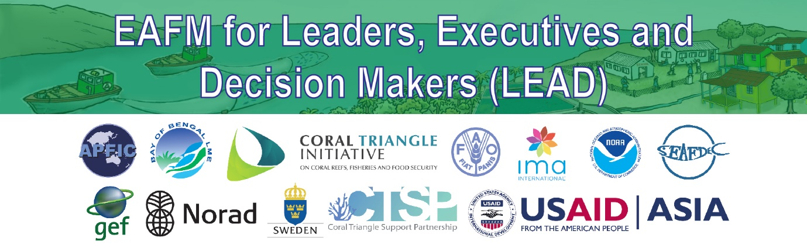
B6: Reference material

EAFM Example

PURPOSE:
This document explains the current status of the country
- To help leaders understand the EAFM concept
- Demonstrate how the country adopted and applied the EAFM principle and moved toward EAFM (case study)
- It is to provide a local example or case study

HOW TO USE THIS DOCUMENT
- It is a handout to be present to the leaders
- For the briefer “EAFM concept is not new in our region, here is a local case study to show the experience”

CASE STUDY

Country: Samar Sea, Philippines (EAFM Samar Sea Fisheries Management Plan)

Situation before application of EAFM (issues): Conflict between large-scale and small-scale fisher; crowded fishing gears in the areas. There was an informal agreement issued by the local government unit of the Philippine Bureau of Fisheries & Aquatic Resources (BFAR) that targeted small scale fishers in order to allow for commercial fishers to fish in a certain area. The local government decided on a fisheries zone but it wasn’t supported by science and the inventory of fishing gears.

Vision: A Sustainable and Equitably Shared Samar Sea Fisheries through Dynamic Management

Goal: To provide for a more sustainable fishery, the key goals are to reduce conflict between different scales and use of destructive fishing gears.

Prior management system: co-management, led by local governments with BFAR as a technical partner (when requested).

When did the process start: 2014

How did the process start: It started with the local government unit asking BFAR for assistance in addressing the conflict. Based on a visit by the REBYC II group, it was decided to further engage in the EAFM. The local unit of BFAR established Key Stakeholder, Technical Working Group (TWG), and National Advisory Group (NAG) as well as carried out socio-economic and trawl surveys. This information was used to populate the planning process.

Political level (scale) of the EAFM process: regional and national of government (BFAR), local government unit, and local academics & universities

Leader of the EAFM process: BFAR carried out the Essential EAFM program in 2014.

Facilitator of the EAFM process: Regional BFAR office in partnership with local universities

Plan Implementer: The plan will be implanted by the members of the Alliance thru a Unified Municipal Ordinances, TWG, and BFAR.

Description of stakeholders and how they are engage: 45 stakeholders from the Samar Sea area. These stakeholders represented the 11 local government unit; regional and national of BFAR; academia, commercial trawl fishing sector, artisanal fishing sector that

Current Step: Step 3 (Objectives, Indicators, Benchmarks & Management Actions). They will begin Step 4 (Do) in August of 2015.

Examples of management indicators and benchmarks: Number of cases of conflict. The expectation would be that under the EAFM, this number will be reduced. Benchmarks are the time frames by which it will be implemented.

How many of the 7 key principles are being applied:
They have practiced 4 key principles: P2 – appropriate scale; P3 - increased participation; P4 – multiple objectives; P5 – cooperation and coordination. [P1, P6 and P7 are assessed after Step 4 & 5.]

Outputs: Report of consultation/ Meeting; Report of studying on icthyoplankton; spawning seasons that will be part of the FMP and the results of data analysing of Socio-economic aspect.

Outcomes: Management plan will be applied in the Samar Sea

Lesson Learned: the involving of stakeholder is important including in the data collection stages. The TWG is an important institution that involves the stakeholders and government in assessing data and jointly making recommendations to the management committee.

